Ex. No. : 05
Register No. : 240701045 Name : Aparna R
Job Application Automation Suite — Workflow Options Use Case

1. Objective
To design and build a complete automation layer in Zoho Creator for the existing "Job
Application" application, demonstrating the correct usage of all eight Workflow options
available in Zoho Creator — Form Workflows, Schedules, Approvals, Payments, Blueprints,
Batch Workflows, Report Workflows, and Functions — so that the recruitment lifecycle runs
with minimal manual intervention from application to onboarding.
2. Problem Statement
The Job_Application_Form and its supporting pages and reports capture and display data well,
but every downstream action currently depends on a human: sending application
acknowledgements, reminding candidates of upcoming interviews, getting sign-off before an
offer is sent, paying out employee referral bonuses once a referred candidate completes
probation, notifying a large batch of rejected candidates, and recalculating the expected CTC
when a candidate's current pay or hike expectation is edited. This manual dependency does not
scale during a hiring surge, and it introduces delay and inconsistency.
Design a complete automation layer on top of the Job_Application_Form in Zoho Creator, using
every Workflow option Zoho Creator provides, so that routine actions happen automatically,
offers are routed for approval before being sent, referral bonuses are paid out without manual
follow-up, and candidate status moves through a controlled, auditable process.
3. Scope of the Use Case
• Application Name: Recruitment & Job Application Management
• Base Form/Report: Job_Application_Form, Candidate_Application_Report
• Primary Users: Candidates (indirect, via automated communication), HR Recruitment
Team, Hiring Managers, Finance/Payroll Team
• Deliverable: Eight automations, one for each Zoho Creator Workflow option, layered onto
the existing recruitment process

• Objective of the Automation Suite: Reduce manual effort, enforce a controlled offer-
approval and status process, and ensure timely communication throughout the hiring lifecycle.

1.Form event
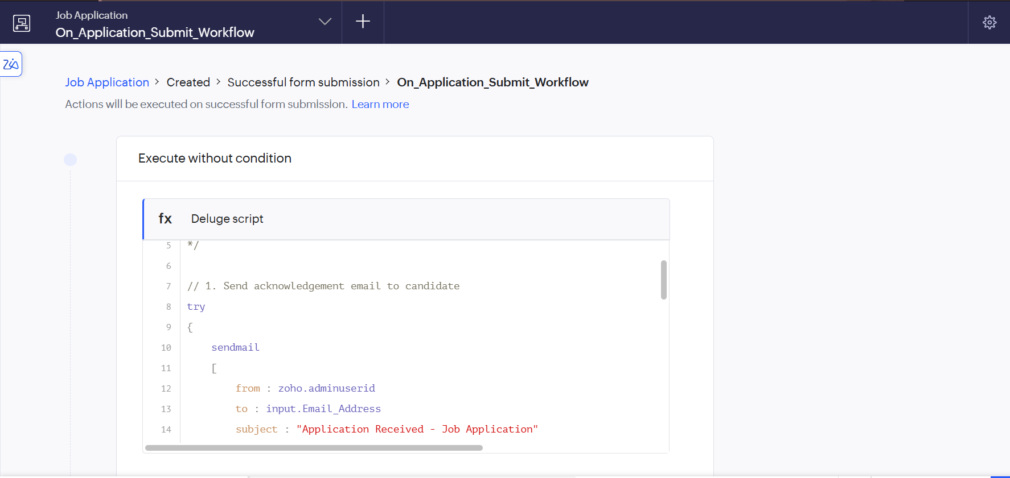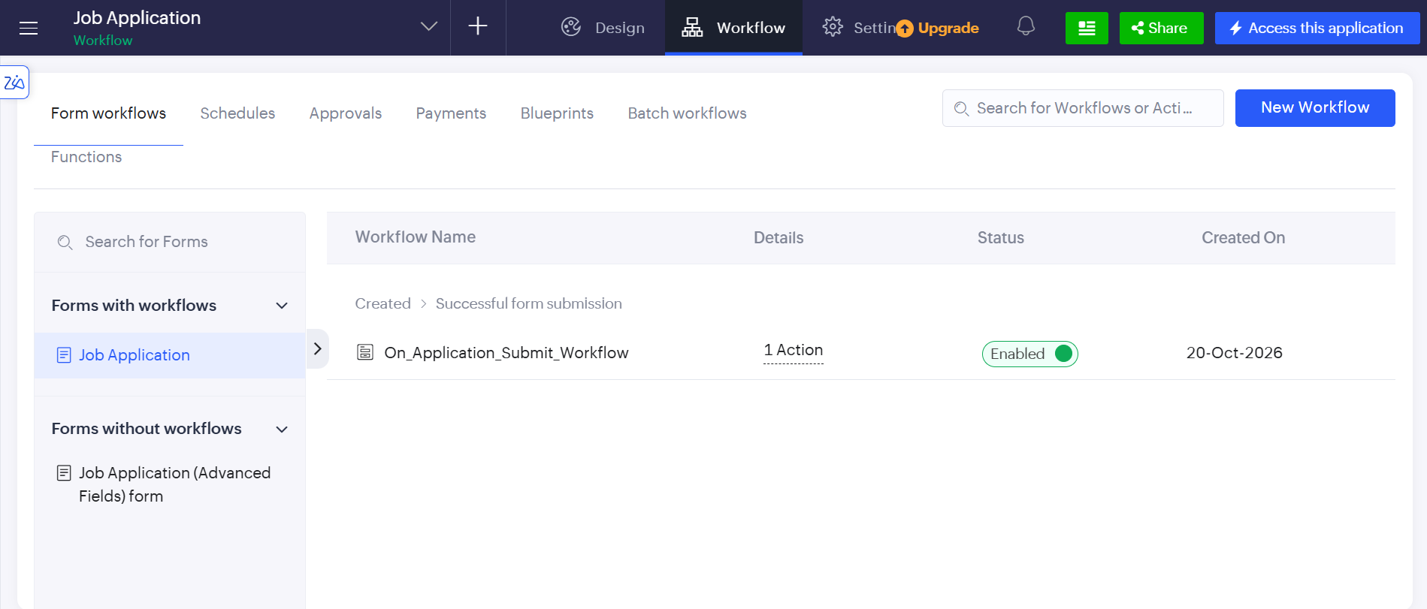

2. Schedules
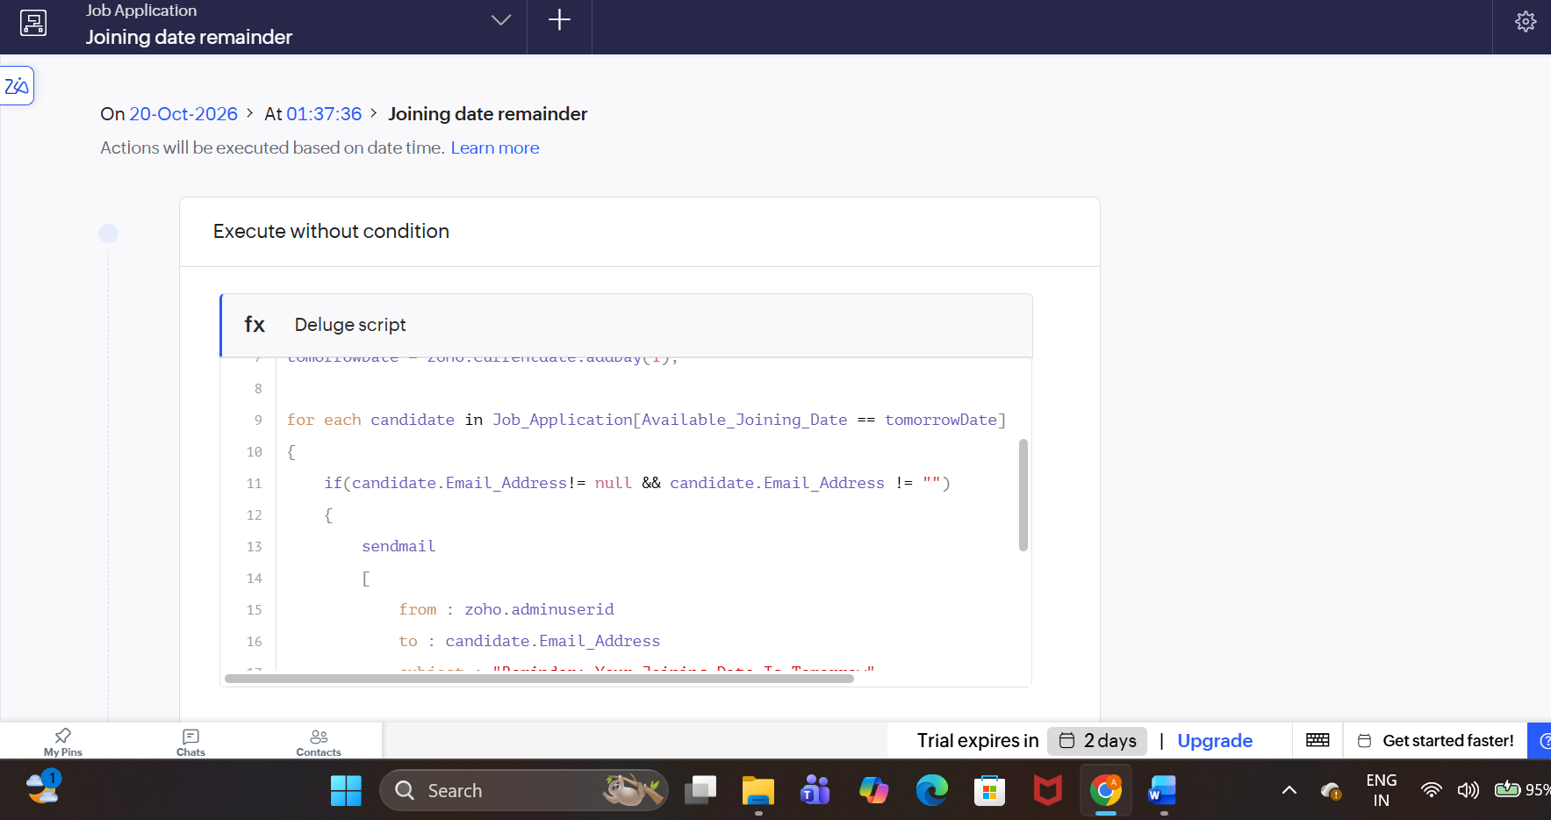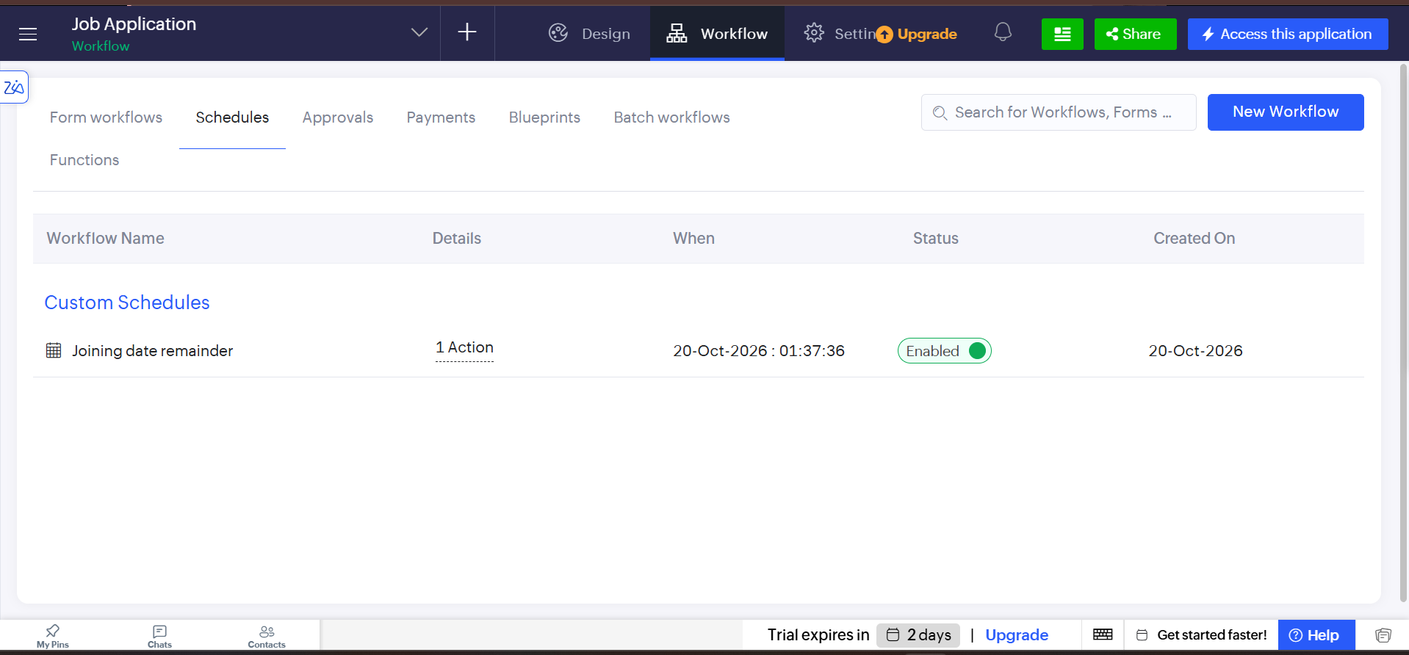

3.Approvals

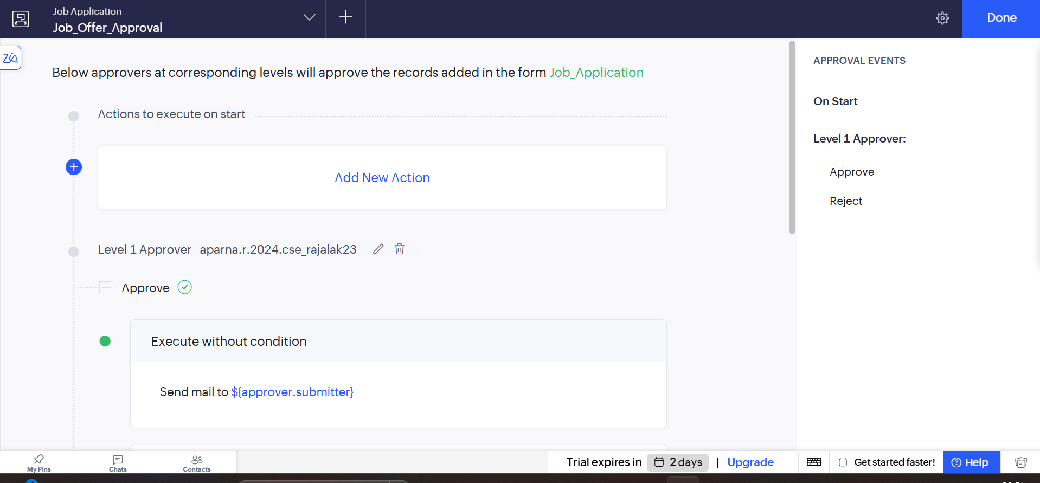
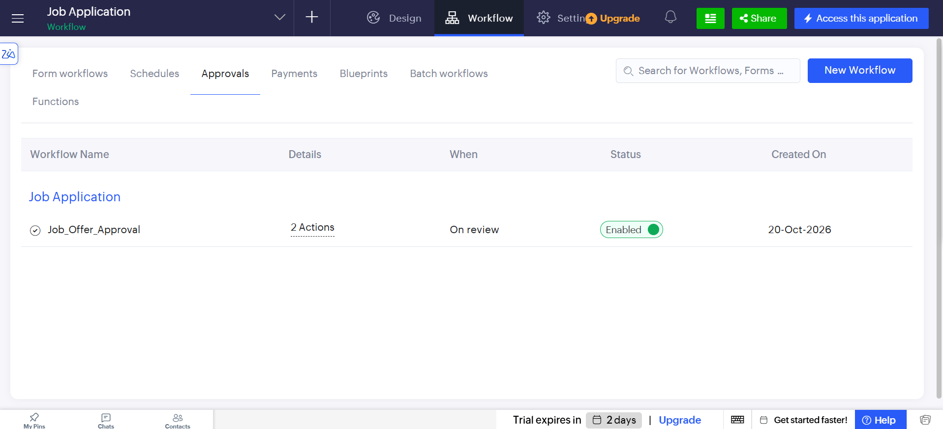

4.Functions
